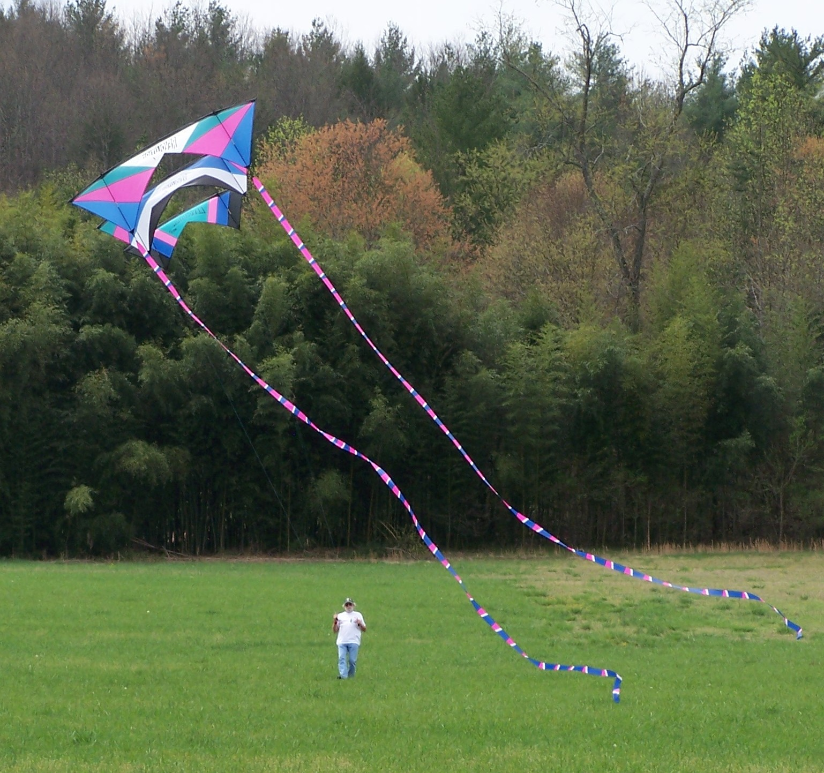
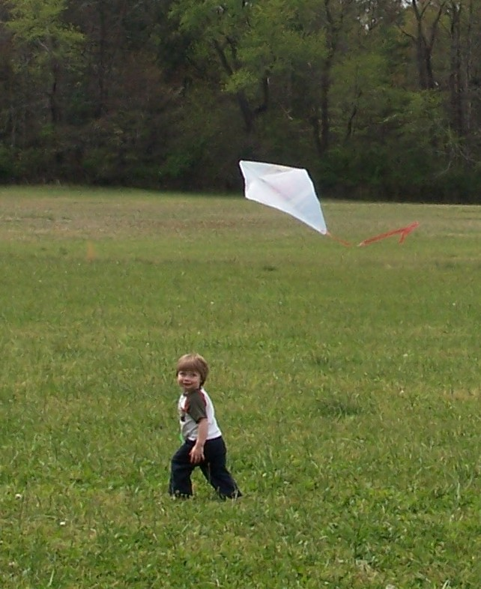
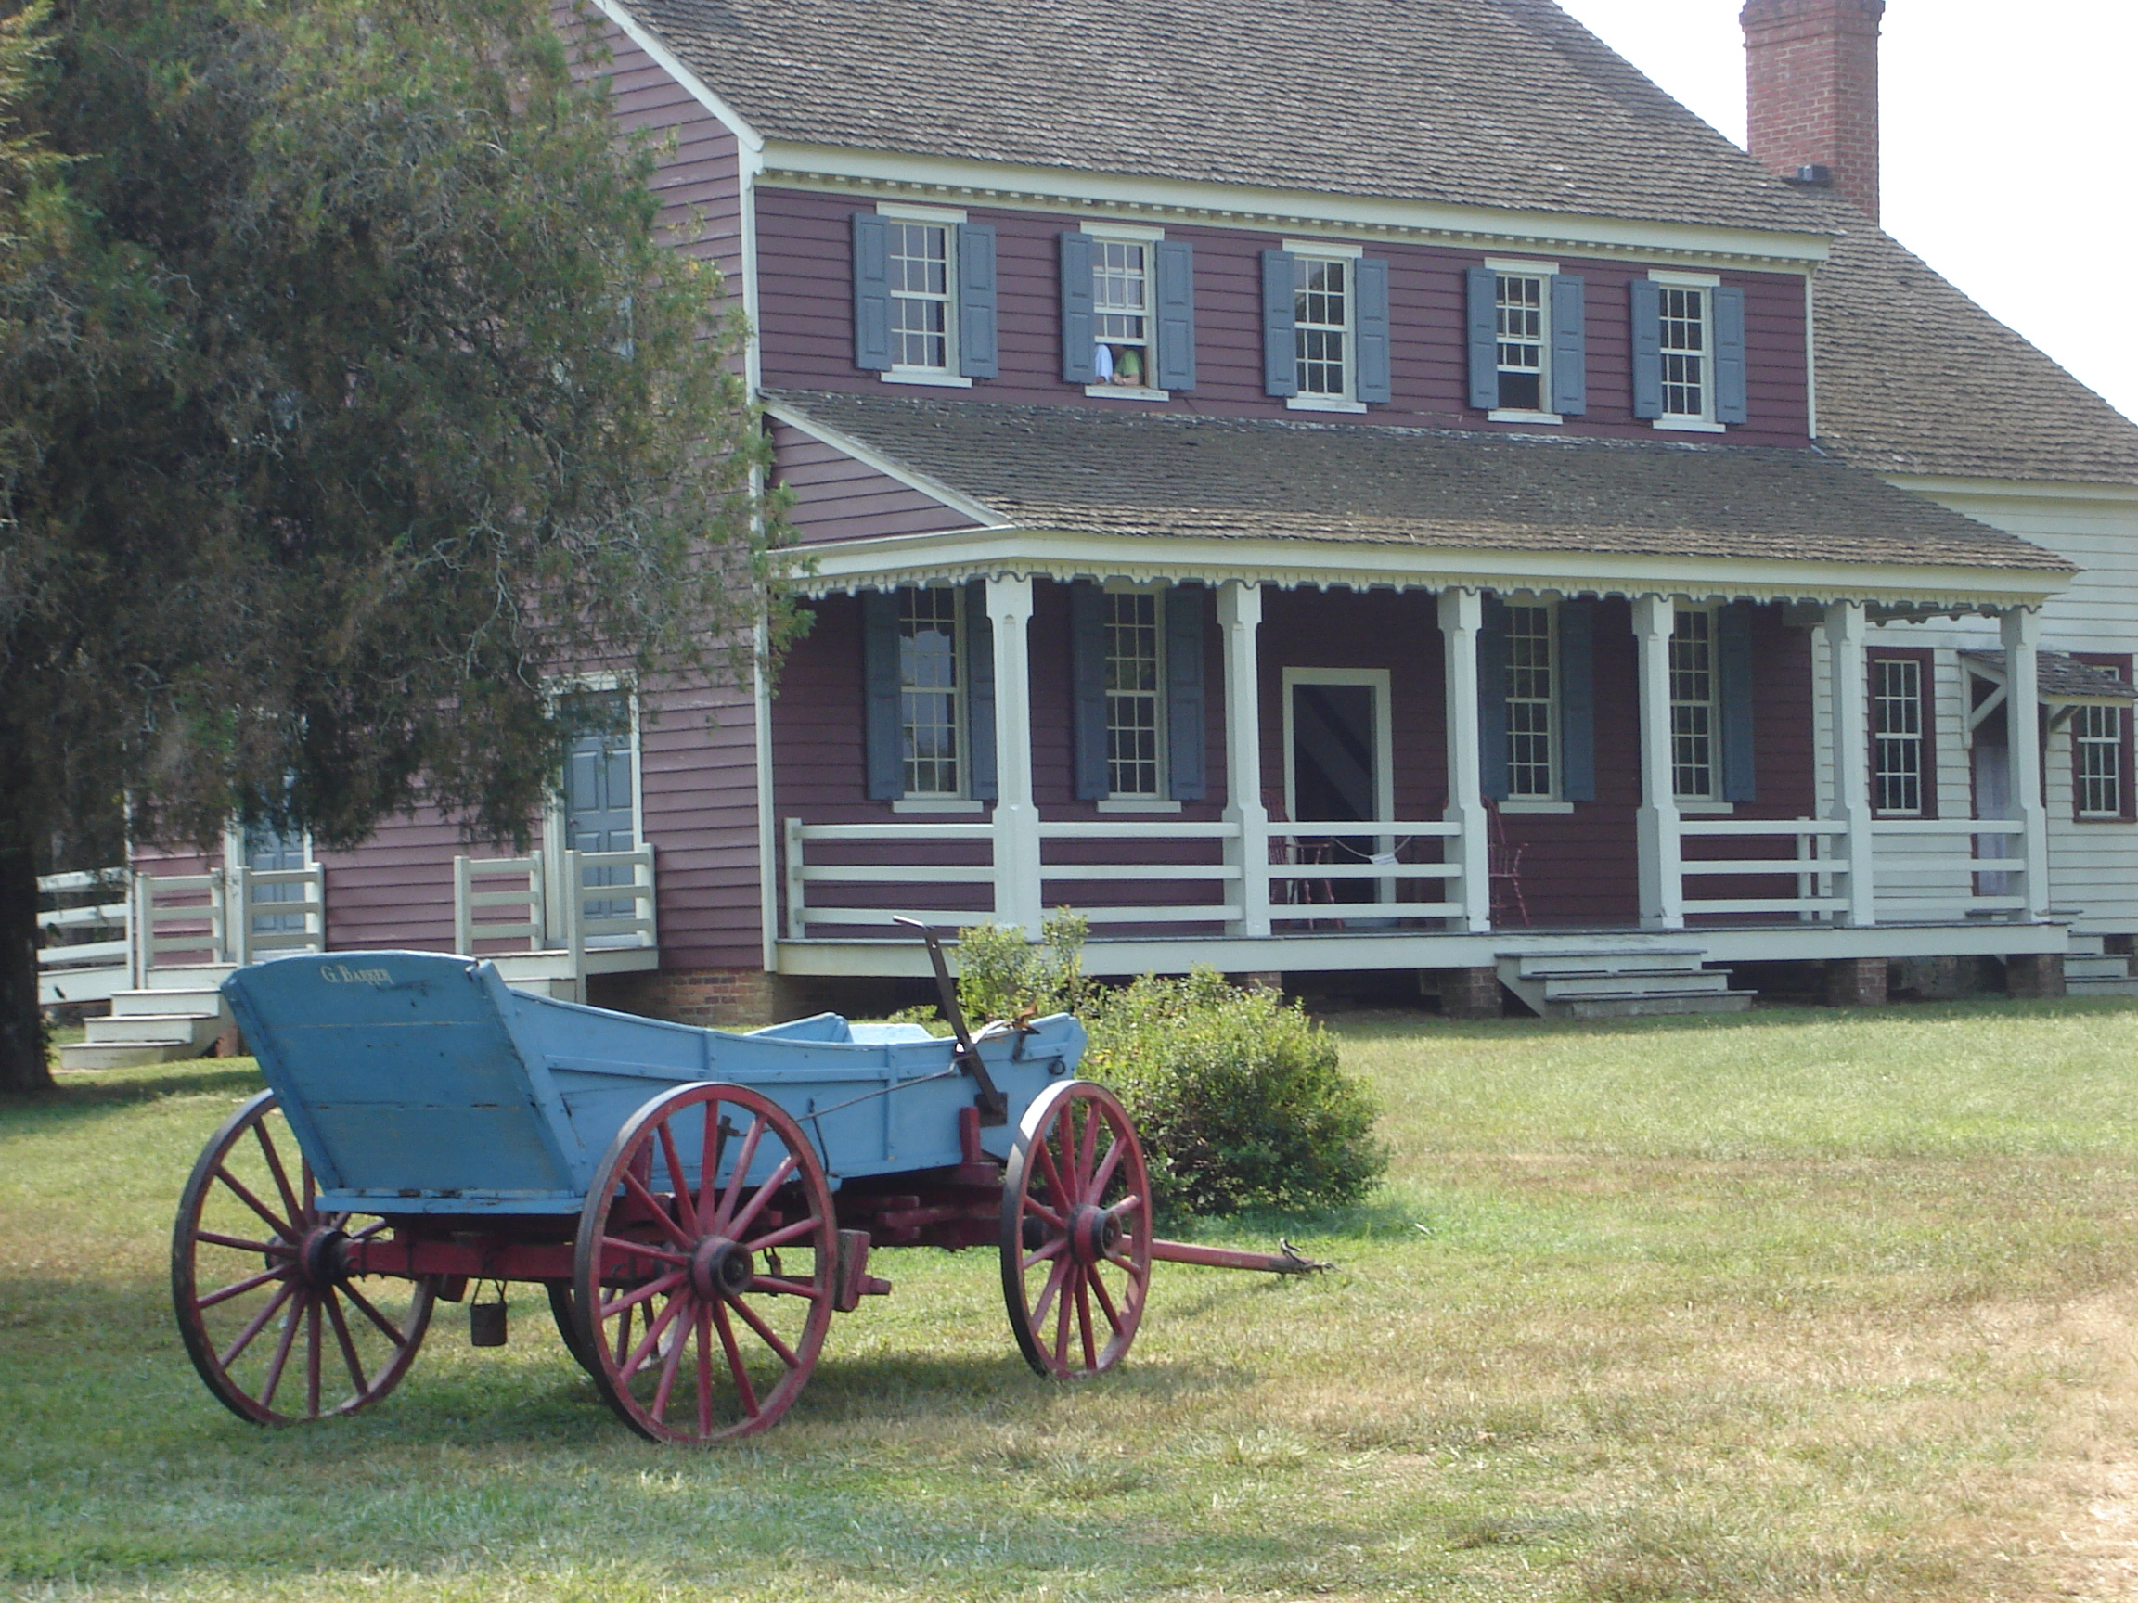
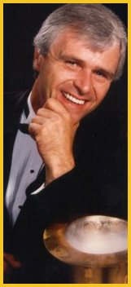
Kite Flying Festival
Fort Defiance
Admission
$3.00
Magic Show
Hwy. 268, just 5.5 miles off Hwy. 321. Call 758-1671 for more info
Kids Kite Making workshops
Concessions available & discounted guided tours of historic house with gate admission.
&
Comedy, Magic & Music shows
With Bill Clary at 11 & 2
Kite flying demonstrations performed by WACKOS
Come fly with us on the historic grounds and
enjoy a day of magical family fun in the wind.
Bring your lawn chair or blanket and spend the day.
May 8th
10 a.m. to 4 p.m.

